\***NMOS DRAIN CHARACTERISTICS\***

.model mosn nmos Vto=0.5 w=1.6u l=0.4u

Mn1 2 1 0 0 mosn

Vds 2 0

Vgs 1 0

.dc Vds 0 5 0.1 Vgs 0 3 0.5

.control

run

plot -i(Vds)

.endc

.end

**\*NMOS TRANSFER CHARACTERISTICS\***

.model mosn nmos Vto=0.5 w=1.6u l=0.4u

Mn1 2 1 0 0 mosn

Vds 2 0

Vgs 1 0

.dc Vgs 0 5 0.1 Vds 0 3 0.5

.control

Run

plot -i(Vds)

.endc

.end

%%%%%%%%%%%%%%

**PMOS Output /Drain Characteristics\***

.model mosp pmos Vto=-0.5 w=1.6u l=0.4u

Mp1 2 1 0 0 mosp

Vds 2 0 dc -3v

Vgs 1 0 -3v

.dc Vds 0 -5 -0.1 Vgs 0 -3 -0.5

.control

run

ploti(Vds)

.endc

.end

**PROGRAM:**

**\*PMOS Transfer characteristics\***

.model mosp pmos Vto=-0.5 w=1.6u l=0.4u

Mp1 2 1 0 0 mosp

Vds 2 0 dc -3v

Vgs 1 0 -3v

.dc Vgs 0 -5 -0.1 Vds 0 -3 -0.5

.control

run

plot i(Vds)

.endc

.end

Boolean expr

**PROGRAM:**

*Transient Response of function=(AB+C)'*

.model mosnnmosvto=0.5

.model mosppmosvto=-0.5

mp1 6 3 1 1 mosp

mp2 2 4 1 1 mosp

mp3 6 5 2 2 mosp

mn1 6 3 7 7 mosn

mn2 7 4 0 0 mosn

mn3 7 5 0 0 mosn

vdd 1 0 3

vin1 3 0 pulse (0 3 0 1ns 1ns 50ns 100ns)

vin2 4 0 pulse (0 3 0 1ns 1ns 50ns 200ns)

vin3 5 0 pulse (0 3 0 1ns 1ns 50ns 150ns)

.tran 0ns 500ns 0.01ns

.control

run

reset

plot v(6) 4+v(3) 8+v(4) 12+v(5)

.endc

.end

*v must

NOR

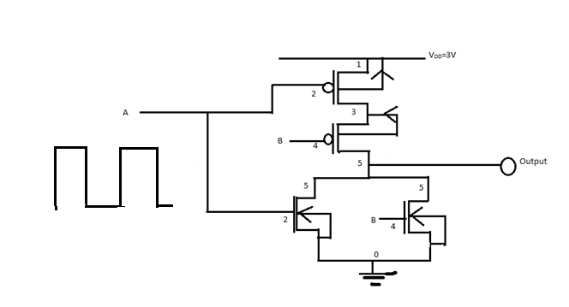

**PROGRAM:**

*Transient Response of nor gate to pulse input*

.model mosn nmos vto=0.5

.model mosp pmos vto=-0.5

vdd 1 0 3

vin1 2 0 0

vin2 4 0 0

*vin1 2 0 pulse(0 3 0ns .01ns .01ns 50ns 100ns)

*vin2 4 0 pulse(0 3 0ns .01ns .01ns 100ns 200ns)

mn1 5 2 0 0 mosn

mn2 5 4 0 0 mosn

mp1 3 2 1 1 mosp

mp2 5 4 3 3 mosp

vin1 2 0 pulse (0 3 0 1ns 1ns 50ns 100ns)

vin2 4 0 pulse (0 3 0 1ns 1ns 50ns 200ns)

*vin1 2 0 pulse(0 3 0ns .01ns .01ns 50ns 100ns)

*vin2 4 0 pulse(0 3 0ns .01ns .01ns 100ns 200ns)

.tran 0ns 500ns 0.01ns

*.tran 0ns 1000ns 0.01ns

.control

run

reset

plot v(2) 4+v(4) 8+v(5)

.endc

.end

NAND

Draw CMOS design for NAND diagram

*2-ip NAND Gate

.model mosn nmosvto=0.5

.model mosp pmosvto=-0.5

vdd 1 0 3

m1 5 2 3 3 mosn

m2 3 4 0 0 mosn

m3 5 2 1 1 mosp

m4 5 4 1 1 mosp

vin1 2 0 pulse(0 3 0 1ns 1ns 50ns 100ns)

vin2 4 0 pulse(0 3 0 1ns 1ns 50ns 200ns)

.tran 1ns 500ns 0.01ns

.control

run

reset

plot v(5) 4+v(4) 8+v(2)

.endc

.end